

MAWLANA BHASHANI SCIENCE AND TECHNOLOGY UNIVERSITY

Santosh,Tangail-1902

LAB REPORT

Lab Report No : 02

Lab Report name : Command of Linux Operating System

Course Title : Operating System Lab

Course Code : ICT-3110

Date of Performance : 28/09/2020

Date of Submission :30/09/2020

Submitted by,

Student Name : Fatema Tuj Jannat

Student ID : IT-18028

Session : 2017-18

3rd Year 1st semester

Dept. of ICT

Submitted to,

Nazrul Islam

Assistant Professor

Dept. of ICT,

MBSTU.

# Name:Fatema Tuj Jannat

# ID:It-18028

# Course:Operating System

# Lab Report 02:Basic Command of Linux Opearting System

# Lab Report 02:Basic Command Of Linux Operating System

# What’s Linux Command:

1. A command is an instruction given by a user telling a computer to do something, such a run a single program or a group of linked programs. Commands are generally issued by typing them in at the command line and then pressing the ENTER key, which passes them to the shell.
2. A shell is a program that reads commands that are typed on a keyboard and then executes them. Shells are the most basic method for a user to interact with the system. Every Unix-like operating system has at least one shell, and most have several. The default shell on most Linux systems is bash.
3. A program is a sequence of instructions that is understandable by a CPU the main logic unit of a computer. It indicates which operations the CPU should perform on a set of data. Programs are usually files that are stored in one of the bin directories, such as /bin, /usr/bin and /usr/local/bin.
4. Commands on Unix-like operating systems are either built-ins or external commands. The former are part of the shell. The latter consist of both executables, which are programs that have been written in a programming language and then compiled into a binary, and shell scripts.

# commands of Linux operating system:

### 1.pwd command

Use the **pwd** command to find out the path of the current working directory (folder) you’re in. The command will return an absolute (full) path, which is basically a path of all the directories that starts with a forward slash **(/)**. An example of an absolute path is **/home/username**.

### 2. cd command

To navigate through the Linux files and directories, use the **cd** command. It requires either the full path or the name of the directory, depending on the current working directory that you’re in.

On a side note, Linux’s shell is case sensitive.

### 3. ls command

The**ls** command is used to view the contents of a directory. By default, this command will display the contents of your current working directory.

### 4. cat command

**cat** (short for concatenate) is one of the most frequently used commands in Linux. It is used to list the contents of a file on the standard output (sdout). To run this command, type **cat** followed by the file’s name and its extension. For instance: **cat file.txt**.

Here are other ways to use the **cat** command:

**cat > filename**creates a new file

**cat filename1 filename2>filename3**joins two files (1 and 2) and stores the output of them in a new file (3)

to convert a file to upper or lower case use, **cat filename | tr a-z A-Z >output.txt**

### 5. cp command

Use the **cp** command to copy files from the current directory to a different directory. For instance, the command **cp scenery.jpg** **/home/username/Pictures** would create a copy of **scenery.jpg** (from your current directory) into the **Pictures** directory.

### 6. mv command

The primary use of the **mv** command is to move files, although it can also be used to rename files.

The arguments in mv are similar to the cp command. You need to type **mv**, the file’s name, and the destination’s directory. For example: **mv file.txt /home/username/Documents**.

To rename files, the Linux command is **mv oldname.ext newname.ext**

### 7. mkdir command

Use **mkdir** command to make a new directory — if you type **mkdir Music** it will create a directory called **Music**.

### 8. rmdir command

If you need to delete a directory, use the **rmdir** command. However, rmdir only allows you to delete empty directories.

### 9. rm command

The **rm** command is used to delete directories and the contents within them. If you only want to delete the directory — as an alternative to rmdir — use **rm -r**.

### 10. touch command

The **touch** command allows you to create a blank new file through the Linux command line. As an example, enter touch **/home/username/Documents/Web.html** to create an HTML file entitled **Web** under the **Documents** directory.

### 11. locate command

You can use this command to **locate** a file, just like the search command in Windows. What’s more, using the **-i** argument along with this command will make it case-insensitive, so you can search for a file even if you don’t remember its exact name.

To search for a file that contains two or more words, use an asterisk **(*)**. For example, **locate -i school*note** command will search for any file that contains the word “school” and “note”, whether it is uppercase or lowercase.

### 12. find command

Similar to the **locate** command, using **find** also searches for files and directories. The difference is, you use the **find** command to locate files within a given directory.

### 13. grep command

Another basic Linux command that is undoubtedly helpful for everyday use is **grep**. It lets you search through all the text in a given file.

To illustrate, **grep blue notepad.txt** will search for the word blue in the notepad file. Lines that contain the searched word will be displayed fully.

### 14. sudo command

Short for “**SuperUser Do**”, this command enables you to perform tasks that require administrative or root permissions. However, it is not advisable to use this command for daily use because it might be easy for an error to occur if you did something wrong.

### 15. df command

Use **df** command to get a report on the system’s disk space usage, shown in percentage and KBs. If you want to see the report in megabytes, type **df -m**.

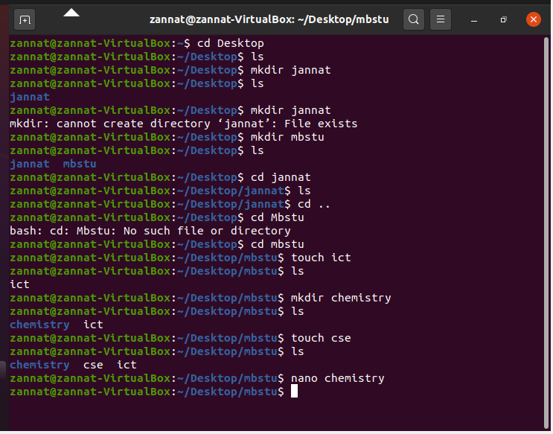

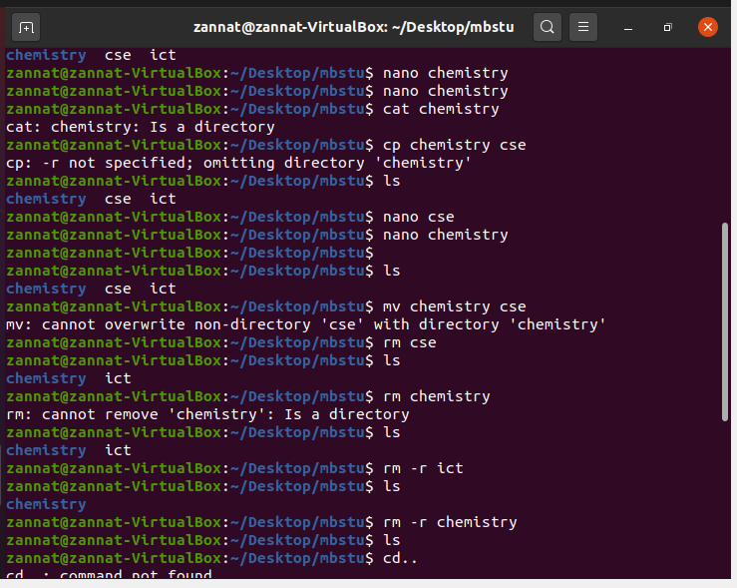

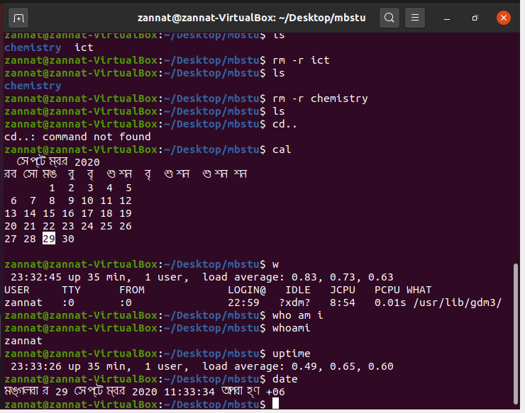

# Conclusion:

The Linux command line will be used extensively in ECPE 170. This lab is intended to give you a basic introduction to navigating on the command line and performing common tasks. You will build upon these skills for the remainder of the course. By the end of the semester the command line should be second nature to you.